VySkan
Product Name | 4G LTE Compact Vehicle GPS Tracker
Product Model | VN-Lite
Compact. Intelligent. Secure
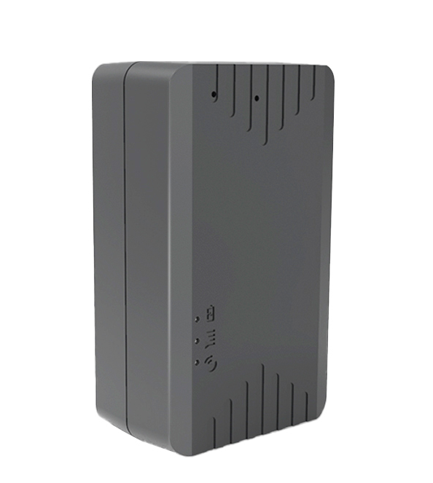
Engineered for advanced vehicle telematics, the Vyskan VN-Lite is a 4G LTE wireless GPS positioning terminal. Powered by a high-performance 32-bit STM MCU and equipped with a 1500mAh battery , it integrates multi-mode GPS/BDS tracking and a 3-axis accelerometer for intelligent wake-up and motion detection. With its highly integrated FPC antenna design and IP65 robust enclosure , it is the ideal tracking solution for enterprise fleets, car rentals, and auto finance.
- Core Value
- Dynamic Smart Power Management
Features three adaptable working modes—Normal, Power-Saving, and Smart—allowing users to perfectly balance high-frequency positioning with extended battery life based on actual field requirements.
- Zero Data Loss Guarantee
Built-in large-capacity flash memory automatically caches trajectory data when vehicles enter cellular blind spots, seamlessly re-uploading upon network recovery to ensure 100% operational visibility.
- Proactive Fleet Security
An integrated 3-axis accelerometer instantly detects vehicle posture, triggering real-time vibration and over-speed alarms, while virtual geofencing instantly alerts platforms of unauthorized asset movement.
- Target Applications
- Car Rental & Leasing: (Compact 53x31x20mm dimensions and 42g lightweight design allow for extreme concealment, protecting assets without detection ).
- Enterprise Fleet Management: (Reliable TCP/IP data transmission and blind-spot compensation provide fleet managers with uninterrupted route and speed data ).
- Auto Finance & Insurance: (Instant vibration alerts and precise geofencing provide immediate notification of theft or unauthorized towing ).
- Technical Specifications
  - Cellular & GNSS
Category | Specification | Description
Network Bands | 4G LTE-FDD & 2G GSM | LTE-FDD:B1/B3/B5/B7/B8/B20(Optional); GSM: B3/B8).
Positioning Mode | BDS + GPS | Dual-constellation tracking ensures highly accurate visibility.
Startup Time | Cold:Avg 32s  Hot: Avg 1s | Rapid Time-To-First-Fix (TTFF).
Sensitivity | -162 dBm | Maintains strong satellite lock via anti-interference ceramic antennas.

  - Power & Electrical
Category | Specification | Description
Battery Capacity | 1500 mAh | Dedicated internal battery power supply.
Working Voltage | DC 3.4V - 4.5V | Stable internal electrical architecture.
Working Current | Avg 55mA @ 4V | Efficient power utilization during active data transmission.
Sleep Current | Avg 6mA @ 4V | Ultra-low drain during idle periods to maximize longevity.
  - Interfaces & Expandability
Category | Specification | Description
Sensor | 3-Axis Accelerometer | Enables intelligent wake-up, vibration alarms, and over-speed detection.
Data Interface | Flash Storage | Caches data during cellular drops for seamless upload upon reconnection.
Expandability | OTA Support | Enables remote firmware upgrades and parameter configuration.
  - Physical & Environmental
Category | Specification | Description
Dimensions | 53mm × 31mm × 20mm | Ultra-compact design easily adaptable for covert vehicle deployment.
Weight | 42g (Host) / 118g (Total) | Exceptionally lightweight ABS plastic construction.
IP Rating | IP65 | Resists dust ingress and water, ensuring durability.
Operating Temp. | -20℃ to 75℃ | Robust industrial-grade resilience in diverse climates.
- Deployment & Integration
Unobtrusive Deployment & Seamless Integration: The VN-Lite features a self-ejecting Nona SIM card slot for quick field deployment. It utilizes standard TCP/IP data transmission methods, connecting via domain or IP address for seamless integration into existing software architectures. Furthermore, it fully supports Over-The-Air (OTA) remote firmware upgrades and parameter configuration, completely eliminating the need for physical device retrieval during maintenance.
- A personalized service prepared for you
- 1× VN-Lite Sample Device (Pre-configured)
- Full API & Protocol Documentation
- 1-on-1 Technical Support from our Field Engineers
- Contact us
Website: https://vyskan.com/
Email: marketing@vyskan.com

